


COE/ELE 70AB Milestones Compliance Report (MCR)
Project Title | MZ02 - AI-Powered Clinical Decision Support - Predicting Drug–Drug Interactions
MCR Number | II (weeks 6 & 7)
Project Manager for the MCR period | Ahraz Kibria, “Student C”, responsible for weeks 6 & 7 activities and report in Week 7, Friday afternoon)
Team Players for the MCR period | Taha Ghori, Ahraz Kibria, Raidah Nazimuddin, Kartike Chaudhari
Faculty Supervisor | Muhammad Rehman Zafar

Tasks Outlined for the Reporting Period: MCR I – Weeks 6 & 7

Group: Formalize the selection of the primary dataset, model architecture, and target platform. Synthesize individual design components into a preliminary, integrated project design
Student A: Design the complete data preprocessing pipeline.
Student B: Draft the theoretical design document for the selected AI model.
Student C: Draft a high-level system architecture diagram.
Student D: Design the high-level logic for the risk-scoring system.

Progress Made in Reporting Period(Provide detailed information on the progress that you (as a group and individual) made during the reporting period. You can include figures, datasheets, flowcharts, etc. and additional information as requested by your FLC. You should use your progress to justify compliance with the tasks outlined for the reporting period, as per the milestones submitted to your FLC in Week 3.

Group:
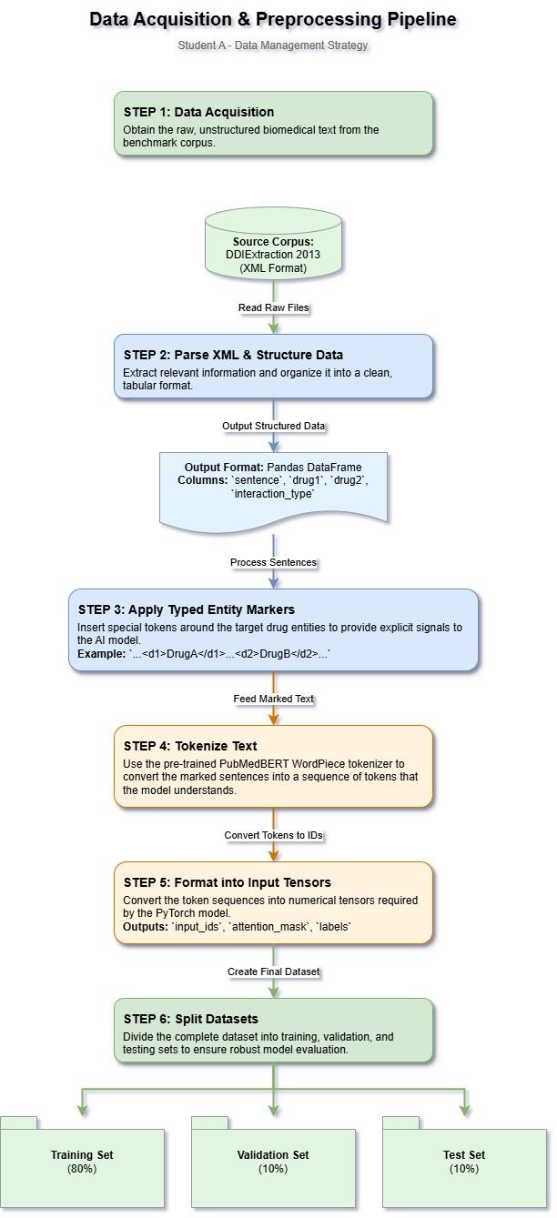
Student A:
Figure 1: This flowchart illustrates the complete, multi-step data pipeline designed to transform the raw DDIExtraction 2013 XML corpus into structured, model-ready tensors for training, validation, and testing. (Subject to change, link: Drawio Link, Drive Link )

During this period, I successfully completed my assigned tasks for weeks 6 and 7 by finalizing the data acquisition strategy and designing the complete preprocessing pipeline needed to feed data into our AI model. I formally selected the DDIExtraction 2013 corpus, reviewed in the previous MCR period, and documented its schema, noting its use of an XML format to annotate drug entities and their interaction types within text from DrugBank and MedLine.
My primary deliverable is the complete data preprocessing pipeline, illustrated in Figure 1. This pipeline consists of several key steps: (1) Parsing the raw XML files, (2) Structuring the data into a tabular Pandas DataFrame, (3) Applying typed entity markers to the text (e.g., <d1>DrugA</d1>), (4) Tokenizing sentences with a PubMedBERT-compatible WordPiece tokenizer, (5) Formatting the data into the required input tensors (input_ids, attention_mask, labels), and finally (6) Splitting the dataset into training (80%), validation (10%), and testing (10%) sets to ensure robust model evaluation.

Student B:
During this reporting period, my focus was on drafting the theoretical design document for our selected AI model, as required by my milestone tasks. I designed a multi-component transformer-based architecture that leverages both PubMedBERT and ClinicalBERT encoders to process diverse biomedical texts. The following points detail the specific design of the model's relation head, the use of auxiliary heads for improved training, and a comprehensive fine-tuning and relation extraction strategy.
Overall Architecture design:
Input Text → Tokenization + Markers → PubMedBERT Encoder + ClinicalBERT branch (better for EHR data) → Relation Head + Auxiliary Heads → Output
- Encoder: PubMedBERT & ClinicalBERT
  - Each source will be processed separately, and then fused later at the relation head of the model
- Relation / Head interaction
  - Create a vector
  - Dense layer activation: Gaussian Error Linear Unit (GELU)
  - Output: multi-class (interaction types) → k neurons + softmax
    - Will give more than just binary insights if DDI
  - Auxiliary heads
    - Classification Head: To determine if a token is a drug, an adverse event, or other, etc.
    - Subtype classification head: mechanism of positive interaction
    - Contrastive/embedding consistency head: for positive vs negative interactions. Helps with consistency in the model.
- Training
  - Use Masked Language Modelling to help train the model better to adapt to our needs
    - Possibly use sub-domain adaptation to help the model become more sensitive to keywords and terminology. This technique is supported in the literature (Su & Vijay-Shanker, 2022)
- Fine-Tuning and Relation Extraction
  - Prepare dataset
    - Use DDI annotated Corpora (Jia et al., 2024)
    - Create negative samples as well
  - categorical cross-entropy for relation classification head
  - Auxiliary losses:
    - Token classification
    - Subtype
  - Weight the positive class heavily for learning
  - Optimizer: AdamW
  - Learning rate decay: linear or cosine schedule
  - Calibrate softmax outputs with possibly temperature scaling
  - Assign a threshold for probability conversion

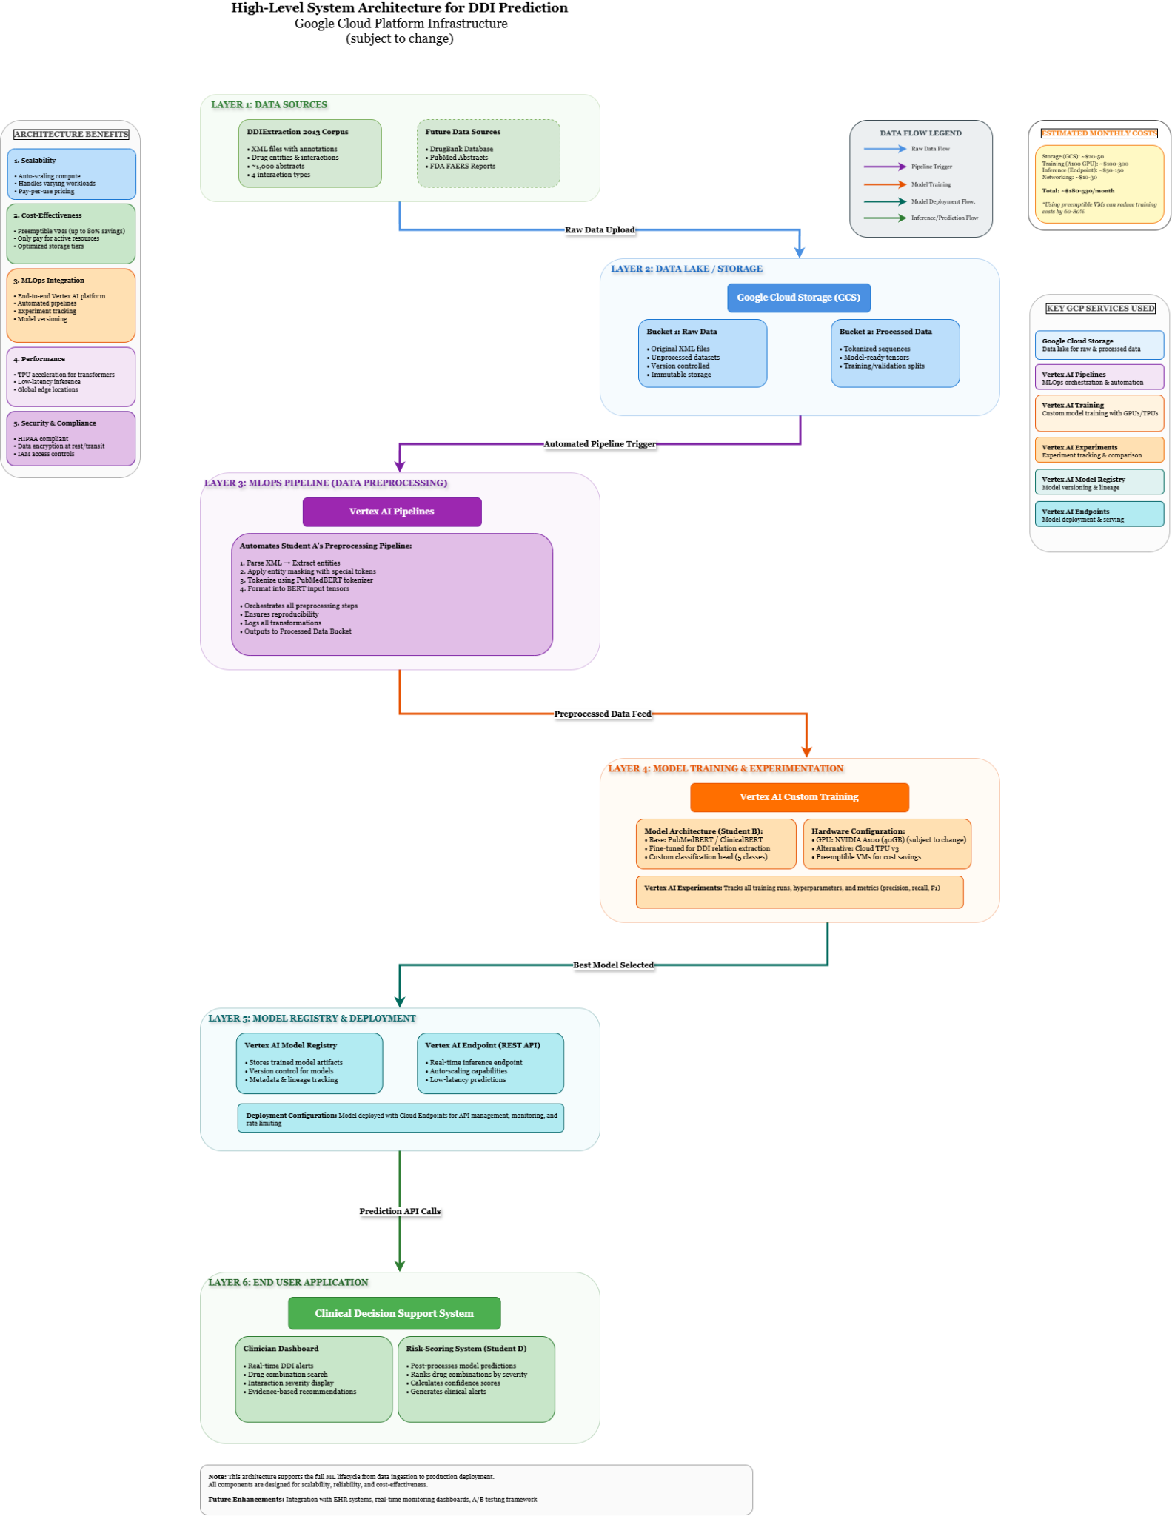
Student C:
Figure 2: The diagram illustrates the end-to-end Machine Learning Operations (MLOps) pipeline. It details the linear workflow from raw data ingestion and preprocessing to the training, experimentation, and eventual deployment of the core AI model as a scalable endpoint. (Subject to change, link: Drawio Link, Drive Link )

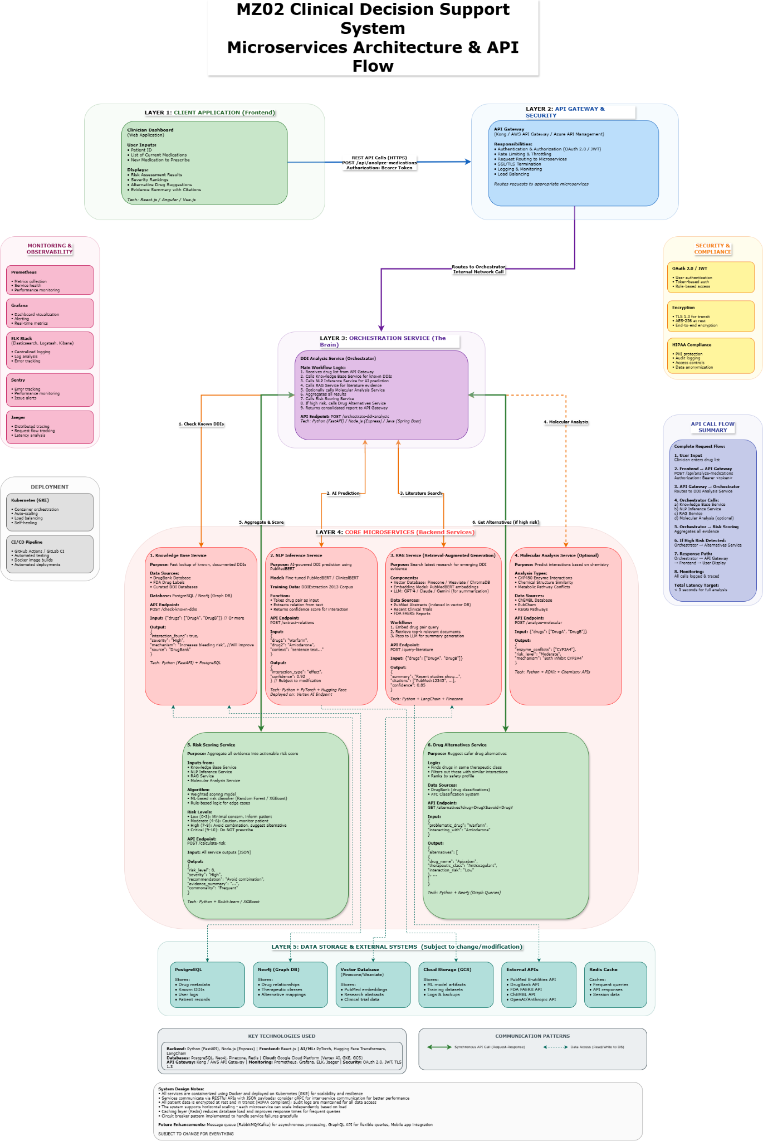
Figure 3: This diagram presents the complete software architecture of the Clinical Decision Support System. It details how the various independent microservices, including the AI model from the MLOps pipeline, collaborate to deliver a cohesive, real-time experience to the clinician. Worked with student B. (Subject to change, most likely not going to use all features, link: Drawio Link, Drive Link )
For this reporting period, I finalized the high-level system architecture for the project. My progress is represented by two distinct but complementary diagrams that define both the overall software structure and the specialized machine learning lifecycle.
1. System Architecture Design (Microservices) We designed a comprehensive (but rough version), system-wide microservices architecture, as detailed in the "System-Wide Microservices Architecture" diagram. This architecture is layered to separate concerns: a frontend client, a secure API gateway, a central orchestrator, and a suite of specialized backend microservices. This design ensures that each component of our system (e.g., AI inference, database lookups, literature search) is an independent, scalable, and maintainable service. This modularity is essential for building a complex and reliable clinical tool.
2. MLOps Pipeline Design To detail the specific lifecycle of our core AI model, I also designed the "MLOps Pipeline for Model Training and Deployment" diagram. This provides a focused view on how we will manage our machine learning assets, from raw data ingestion in Google Cloud Storage (GCS) to automated training with Vertex AI and deployment as a production-ready API endpoint. This MLOps pipeline serves as the "factory" that builds and maintains the NLP Inference Service used within our main microservices architecture.
3. Cloud Platform Justification (GCP) The group has formally selected Google Cloud Platform (GCP). Our architecture strongly justifies this choice:
- Vertex AI: It provides the fully managed infrastructure needed to execute our MLOps pipeline, specifically for training and deploying the NLP Inference Service as a scalable endpoint.
- Google Kubernetes Engine (GKE): GKE is the ideal platform to deploy and manage our entire suite of containerized microservices, offering auto-scaling and resilience.
- Managed Databases & Storage: GCP offers a rich ecosystem of managed storage solutions that map directly to our needs, including Cloud SQL for our relational database, and GCS for our data lake and model artifacts.

Student D:
In line with my milestone task to design the high-level logic for the risk-scoring system, I have developed a complete workflow for this reporting period. The purpose of this system is to translate the AI model's raw probability outputs into a clear, clinically significant risk level that a healthcare professional can act upon. The following workflow details the methodology for normalizing the model's predictions, the weighted calculation used to compute a final risk score, and the thresholds for categorizing that score into low, moderate, or high-risk levels.
Risk-Scoring Workflow:
- Input: Model output probabilities (synergistic, antagonistic, adverse, neutral)
- Normalization: Scale probabilities 0–1; apply temperature scaling (Su & Vijay-Shanker, 2022)
- Weighted Risk Calculation: final risk score $R$ is computed as:
$R=\sum_{i=1}{}P_{i} ×{ W}_{i}​$
- Where ${P_{i}}_{}$​ = normalized probability of interaction type $i$, and $W_{i}$​ = corresponding severity weight
- Risk Categorization:
- Scores are mapped to categorical risk levels:
  - Low Risk (R < 0.3) – minor or unlikely clinical impact
  - Moderate Risk (0.3 ≤ R < 0.7) – possible or context-dependent interaction
  - High Risk (R ≥ 0.7) – clinically significant; requires caution (Luo et al., 2022)
Model Output Probabilities
↓
Normalization
↓
Weighted Risk Calculation
↓
Risk Categorization
↓
Final Risk Level Output
Figure 4: High-Level Flow Diagram of the Risk Scoring System
Integration with Model:
- Post-processing layer after relation-classification head
- Modular design allows adaptation for additional interaction types
Error Handling:
- Low-confidence predictions (<0.2) flagged for manual review
- Improves reliability and interpretability

Difficulties Encountered in Reporting Period (Provide detailed information on the difficulties and issues that you encountered during the reporting period and how you plan to address these in the following periods)

Group:
Student A:
- The primary difficulty was designing a robust parsing script for the DDIExtraction 2013 XML data. I discovered that the corpus contains some structural inconsistencies and occasional annotation errors. This required building a more complex parser with significant validation and error-handling logic to ensure the integrity of the extracted data, which was more time-consuming than initially anticipated.

Student B:
- Researching and developing a model takes a lot of time. This, combined with the ongoing midterm season + assignments, makes it difficult to keep up and plan a correct approach. Will use online AI to help with more tedious tasks and speed up the process, allowing for a more efficient use of time.

Student C:
- The primary challenge was effectively designing and communicating two separate but related architectures. It required careful thought to ensure that the detailed MLOps pipeline (the "how" the model is built) logically fits into the broader microservices architecture (the "what" the final application does) as a single, deployable service. Creating two clear diagrams was essential to prevent confusion and show that they represent two different levels of detail for the same cohesive system.

Student D:
- One difficulty was choosing appropriate severity weights for each DDI category, because different sources define risk levels differently. To address this, the plan is to align the weights with DrugBank’s standardized annotations and validate them using examples from the DDIExtraction 2013 dataset.
- Another challenge was making the risk scores understandable for clinicians. To improve interpretability, explanatory labels, threshold rationales, and visualizations of the score distributions will be added.

Tasks to Be Completed in the Next Reporting Period (Outline the tasks to be completed in the next reporting period. Please note this should match with your milestones submitted to your FLC in Week 3; however, in consultation with (and approval of) your FLC, you can modify this to accommodate incomplete tasks from the previous period. Here, you should also identify the Project Manager for the next period.
Group:
Student A:
- I will finalize our data strategy to ensure robust model training, as outlined in the project milestones. My main task will be to design and document a formal plan for handling the significant class imbalance within the dataset. This plan will specify the implementation details for techniques such as a weighted loss function, justifying the choice based on established biomedical NLP research to prevent model bias. Finally, I will consolidate all data-related designs into the final “Data Management and Preprocessing Plan” document.
Student B:
- In the next reporting period, I will finalize the "AI Model Architecture and Training Plan" document. This involves moving from the theoretical design to a concrete implementation plan. I will specify the exact model layers, activation functions, and output neuron configuration. Critically, I will also document the definitive hyperparameter tuning strategy, defining the ranges for parameters like learning rate and batch size that will be optimized using Vertex AI Vizier. This document will serve as the final blueprint for the model's implementation.
Student C:
- I will finalize the infrastructure design by creating a detailed sequence diagram that maps the precise API call flow between all microservices. In parallel, I will develop a comprehensive cost estimation model for deploying on GCP, working with Student B to determine the most cost-effective AI training strategy by analyzing hardware options and leveraging Preemptible VMs.
- I will consolidate these plans into the "Infrastructure Design and Cost Analysis Document.".
Student D:
- My focus will be on transitioning from design to practical implementation and formalizing our evaluation strategy. First, I will implement a functional Python prototype of the Risk-Scoring Algorithm. This will involve finalizing the severity weights for each DDI category by cross-referencing DrugBank standards and validating them with examples from our dataset. Second, I will draft the formal "Evaluation Metrics and Testing Methodology" document. This will detail our k-fold cross-validation strategy, specify our primary performance metrics (Precision, Recall, F1-Score), and outline the initial plan for clinical relevance testing and error analysis.
- Draft evaluation metrics and testing methodology, including cross-validation and initial error analysis plans.

Bibliography (APA 7)
Devlin, J., Chang, M.-W., Lee, K., & Toutanova, K. (2019). BERT: Pre-training of deep bidirectional transformers for language understanding. Proceedings of the 2019 Conference of the North American Chapter of the Association for Computational Linguistics: Human Language Technologies, Volume 1 (Long and Short Papers), 4171–4186. https://doi.org/10.18653/v1/N19-1423
DrugBank Online. (2024). Drug-Drug Interactions classification and severity scale. https://go.drugbank.com/
Herrero-Zazo, M., Segura-Bedmar, I., Martel, P., & de la Peña, V. (2013). The DDI task: Extraction of drug-drug interactions from biomedical texts. In Proceedings of the 7th International Workshop on Semantic Evaluation (SemEval 2013) (pp. 375–385). Association for Computational Linguistics. https://aclanthology.org/S13-2062
Jia, Y., Wang, H., Yuan, Z., Zhu, L., & Xiang, Z. (2024). Biomedical relation extraction method based on ensemble learning and attention mechanism. BMC Bioinformatics, 25(1). https://doi.org/10.1186/s12859-024-05951-y
Luo, L., Lai, P.-T., Wei, C.-H., Arighi, C. N., & Lu, Z. (2022). BioRED: a rich biomedical relation extraction dataset. Briefings in Bioinformatics, 23(5). https://doi.org/10.1093/bib/bbac282
SemEval. (2013). Task 9: Extraction of Drug-Drug Interactions from Biomedical Texts (DDIExtraction 2013). https://doi.org/10.48550/arXiv.1308.6179
Soares, L. B., FitzGerald, N., Ling, J., & Kwiatkowski, T. (2019). Matching the blanks: Causal analysis of open-domain relation extraction. ArXiv. https://doi.org/10.48550/arXiv.1906.03158
Su, P., & Vijay-Shanker, K. (2022). Investigation of improving the pre-training and fine-tuning of BERT model for biomedical relation extraction. BMC Bioinformatics, 23(1). https://doi.org/10.1186/s12859-022-04642-w
Zhu, L., Yuan, Z., Wang, H., & Jia, Y. (2021). A survey on drug-drug interaction extraction from biomedical text. Journal of Biomedical Informatics, 124, 103943. https://doi.org/10.1016/j.jbi.2021.103943
Google. (2025). Gemini [Large language model]. https://gemini.google.com/.
Appendix: Design Documents
Data Acquisition & Preprocessing Pipeline Figure 1 (PDF View & diagrams.net )
- PDF View: https://drive.google.com/file/d/1758IHQ6hn2hMZ5HosxbSHvDmFpyrrDj9/view
- Editable Diagram: https://app.diagrams.net/?src=about#G1758IHQ6hn2hMZ5HosxbSHvDmFpyrrDj9
- Description: This flowchart provides a detailed, step-by-step illustration of the data pipeline designed to transform the raw DDIExtraction 2013 XML corpus into structured, model-ready tensors for training, validation, and testing.
MLOps Pipeline for AI Model Training & Deployment Figure 2 (PDF View)
- Link: https://drive.google.com/file/d/1758IHQ6hn2hMZ5HosxbSHvDmFpyrrDj9/view
- Description: This document provides a high-level overview of the end-to-end Machine Learning Operations (MLOps) pipeline, detailing the workflow from data ingestion to the training and deployment of the core AI model.
System-Wide Microservices Architecture Figure 3 (PDF View)
- Link: https://drive.google.com/file/d/1AQz5pRVU8y2gfKXqKUpkBkBjUT3rXNkX/view
- Description: This document illustrates the complete software architecture of the Clinical Decision Support System, showing how all independent microservices interact to deliver a cohesive application.
Editable MLOps Pipeline Diagram Figure 2 (diagrams.net)
- Link: https://app.diagrams.net/?src=about#G1758IHQ6hn2hMZ5HosxbSHvDmFpyrrDj9
- Description: The source file for the MLOps Pipeline diagram, allowing for further edits and review.
Editable Microservices Architecture Diagram Figure 3 (diagrams.net)
- Link: https://app.diagrams.net/?src=about#G1AQz5pRVU8y2gfKXqKUpkBkBjUT3rXNkX
- Description: The source file for the System-Wide Microservices Architecture diagram, allowing for further edits and review.

